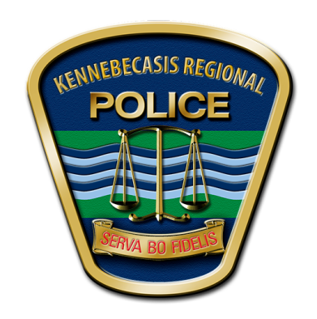
KENNEBECASIS
REGIONAL POLICE FORCE/ FORCE DE POLICE RÉGIONALE

Kennebecasis Regional Police Force Force de Police Régional Kennebecasis
126 Millennium Drive 126 rue Millennium
Quispamsis, NB E2E 6E6 Quispamsis (N.-B.) E2E 6E6
Tel.: (506)847-6300 / Fax: (506)847-6301 Tel.: (506)847-6300 / Fax: (506)847-6301

Kennebecasis Regional Police Force Receives Donation of Therapy Dog

Quispamsis, NB (May 17, 2019) – The Kennebecasis Regional Police Force (KRPF) has a new addition to the force to assist with stressful incidents, thanks to the generous support of a local non-profit organization.

Canine Therapy for First Responders, a new non-profit organization based in Saint John, approached Chief Wayne Gallant about the donation of an assisted-therapy dog to help police officers cope with trauma they face on the job. Assisted therapy dogs are dogs that provide comfort and support in forms of affection and companionship for persons suffering from various mental and emotional stressors. Canine Therapy for First Responders was founded to offer therapy dogs for first responders and agencies in Atlantic Canada. They have now donated their first therapy dog to KRPF.

The new KRPF officer, named Rosa, is a female chocolate Labrador Retriever, bred by Atlantic Coast Labradors. Rosa is 4 months old and is eager to begin bonding and training with her new handlers, Cpl. Lindsey Mott-Haines and Cpl. Aaron Haines. Both officers have committed to an intensive training program that is being led by Canine Therapy for First Responders President & Certified Trainer and Behaviour Consultant, Bev Wells. “I see a great deal of potential in Rosa, and I’m optimistic that she will meet the needs of the police force with consistent training.”
In addition to Rosa, Canine Therapy for First Responders is donating the cost of training for Rosa and her handlers.

Dogs, such as Rosa are increasingly being used by first responders across Canada and the United States. The KRPF Therapy Dog Program was modelled to some degree after the program at the Franklin County Sherriff’s Department (Ohio). They provided their policy and operating model and the KRPF adapted that model to suit their needs here in New Brunswick.

Several sponsors have offered generous support for Rosa providing dog food from Corey Nutrition, various supplies from Global Pet Foods, and kennel fencing provided by a Saint John company, to name a few key contributors.

Chief Wayne Gallant states “The KRPF is thrilled to have Rosa join our ranks. We want to thank Canine Therapy for First Responders and all of Rosa’s sponsors for making this possible. Once trained, Rosa will be an integral part of providing support to our officers, victims of crime and trauma, and also play a key role in the delivery of our community policing programs.”

A therapy dog usage policy has been developed, and given that the program is in its infancy, the KRPF expects the program to evolve over time.

Rosa is expected to begin regular training for her assisted therapy dog certification in June.

See attached photograph.

Follow Rosa on Twitter: @ROSAKRPFK9

Media Contact: Inspector Anika Becker can be reached at (506)848-5401 or anika.becker@nbpolice.ca

